A

Report

On

World Philosophy Day 2021

Session :2021-22

Department of Philosophy

Rabindra Mahavidyalaya,

champadanga, Hooghly

Theme: World Philosophy Day and Quiz

Venue: Rabindra Mahavidyalaya

Department of Philosophy

Room no 71

Date:18th November 2021

Organizer: Department of Philosophy

Objectives (world philosophy day and quiz):

- to understand and respond to major contemporary challenges by creating the intellectual conditions for change.
- Realizing the Value of philosophy
- To celebrate the importance of philosophy to humanity, both as a method of critical thought and a treasure trove of cultural ideas
- Students can do critical thinking, and get inti a habit of innovative learning
- To give a clear understanding of various subjects
- To identify what they know and what they don’t know
- To measure growth in knowledge, abilities, and skills,
- To evaluate the knowledge of the students
- To feel more confident to discuss the material
- For the development of thinking
- Revealing other talent

summary

On November 18^{th,} 2021, World Philosophy Day was celebrated in the Department of Philosophy. By celebrating World Philosophy Day each year, on the third Thursday of November, UNESCO underlines the enduring value of philosophy for the development of human thought, for each culture and for each individual. First, Professor Soumitra Dashead of the Department the lamp lighting in front of Radhakrishnan's portrait. In the portrait, flowers and garlands were given by prof. Hasina Sikhdarand prof. SanchitaKheto. 4 teachers and 99 students were present in the event.Then the students performed an opening song. A short cultural program of half an hour with dance, song recital etc. After that begins the educational program.
Like every time, an educational part is kept in the World Philosophy Day
celebration.Students are divided into fifteen teams in this competition. Each team had
four students. The quiz consists of four rounds, in the first round the topic is ‘Indian
Philosophy’, in the second round the topic is ‘Western Philosophy’ and in the third roundthe topic is ‘Logic’ And in the fourth round the topic was ‘General Knowledge’. Students perform very well. The audience enjoyed it very much. They learn a lot.

- Three winning teams:.Team B 1st position
        - Susmita Jana
        - Kusum Show
        - Nikita Khanra
        - Arifa Khatun
Team k 2nd position
- Shraddha Karmakar
- Pritam Porel
- Priyanjali Chakraborty
- Jaya Jana
Team H 3rd position
- Sama Banarjee
- Sourav Jana
- ItikaBera
- Amrita Dolui

a

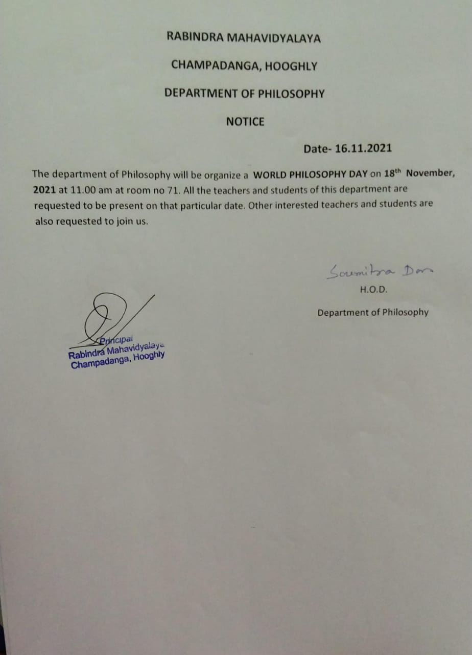

Attendance:

Our participants: 103
Male:21
Female:82

Tentative programmed schedule
- Inaugural session: 11.30a.m. to 11.45a.m.
- Inaugural speech:11.45a.m. to 12 noon
- Other speech: 12noon to 12:30 p.m.
- Cultural programme: 12.30 p.m. to 1.00 p.m.
- Lunch break: 1.00 p.m. to 1:30 p.m.
- quiz: 1:30 p.m. to 3:30 p.m.

Feedback from students:

- 60% felt satisfactory
- 70 percent wished to occur the event more than once every year
- 100 percent students agreed this event helpe to improve their logical performance
- They want special class for grooming, more extra-curricular activities
- They want smart class room

